**Module 8**

Project project code and GitHub link

Renjeev Ramachandran Nair

Colorado State University Global

Course Code: ISM581 – Capstone: Business Intelligence and Data Analytics

Instructor:  Justin Bateh

Due Date: 10/09/2022

**Project Code and Output**

**Figure 1 :**

SAS Program for T-Test and Results

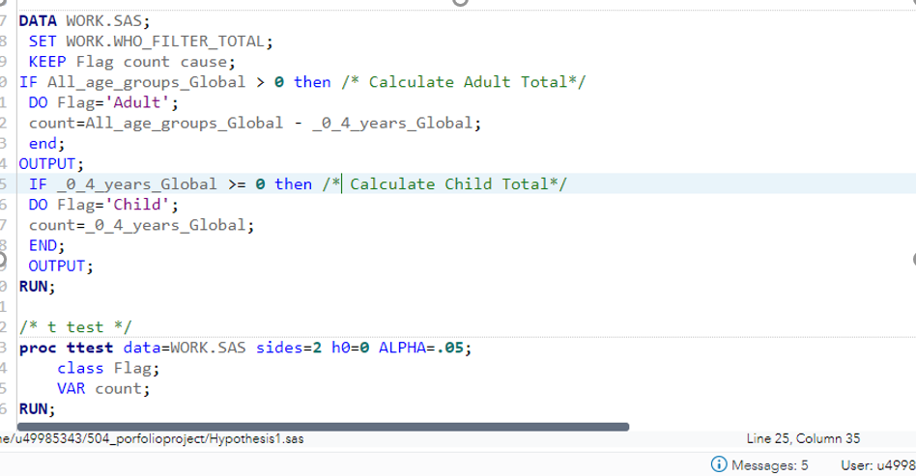

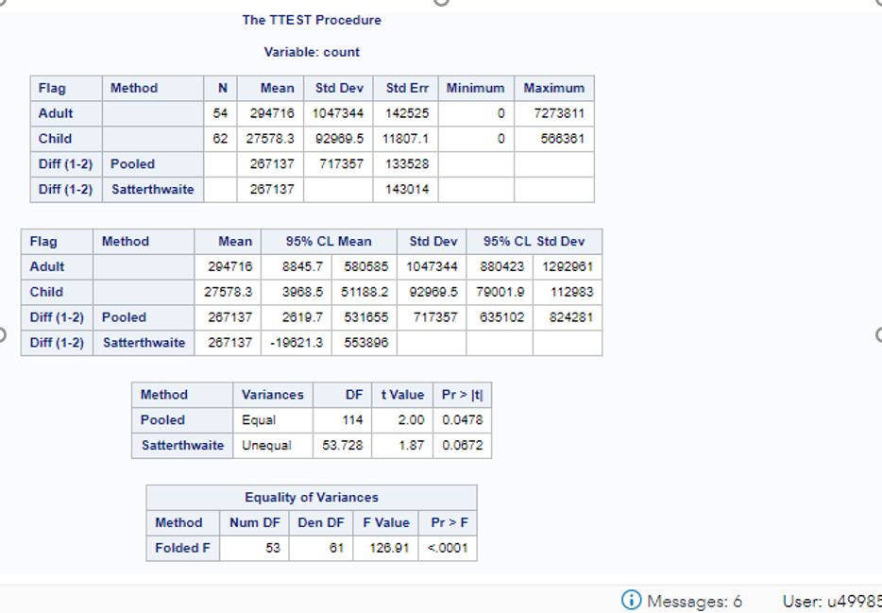

*Note : Extracted using snipping Tool*

Based on the P values of 0.047 lesser than the alpha value of 0.05, we can reject the null hypothesis and can consider that the mortality rates is significantly different between child and adults.

**Figure 2:**

Tableau Bubble chart to compare mortality rates among child and adults.

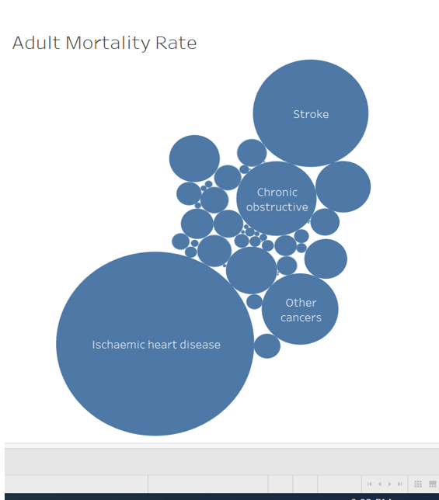

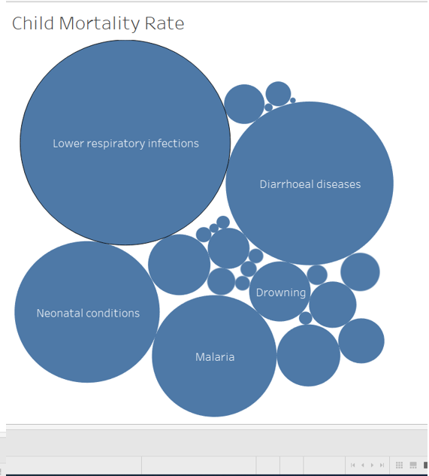

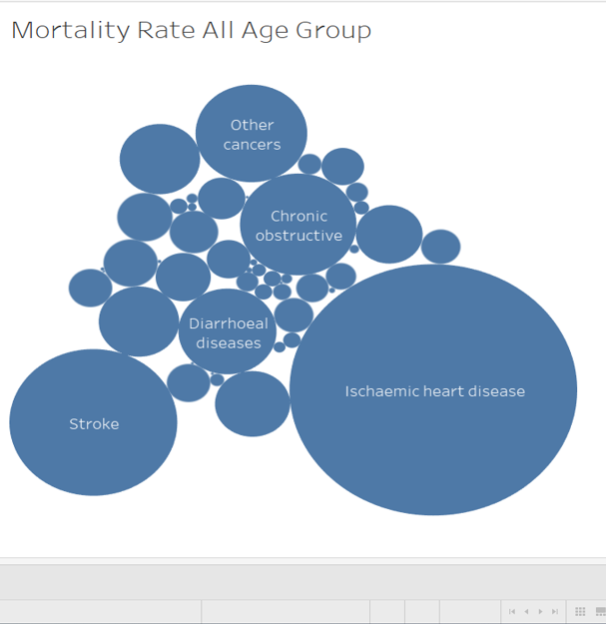

*Note : Extracted using snipping Tool*

The Tableau reports clearly shows that’s adult mortality rates are much higher compared to Children. Also the major death causes are different between Adults and kids. Adults mortality rates are higher due to heart related issues where as kids suffer from diseases mainly due to environmental issues and sanitation problems.

Hypothesis 2

Mortality rates between High income and low-income groups.

**Figure 3 :**

SAS Program for T-Test and Results

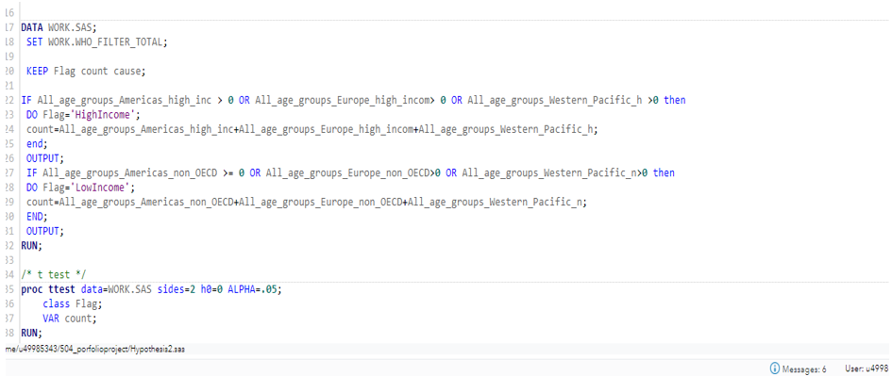

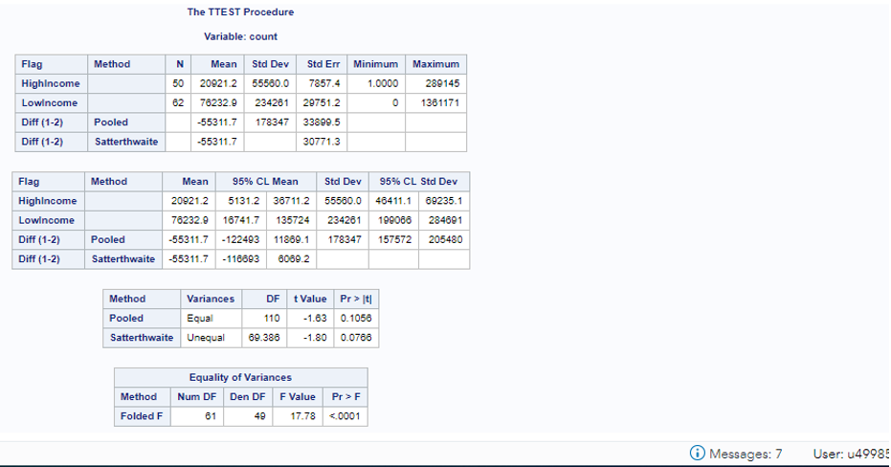

*Note : Extracted using snipping Tool*

There is no significance difference between high value / low value income and hence the Null hypothesis is accepted.

**Figure 4:**

Tableau Bubble chart to view high income mortality rate

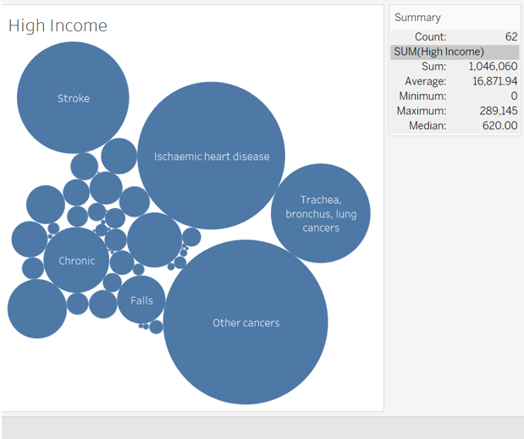

*Note : Extracted using snipping Tool*

**Figure 5:**

Tableau Bubble chart for low income mortality rate

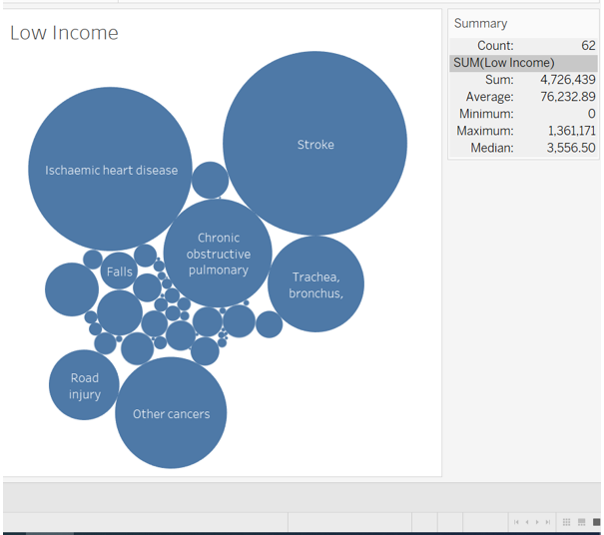

*Note : Extracted using snipping Tool*

Both high income / low income groups are affected by similar diseases and there is no significant differences between them. The health facilities and infrastructure are efficient through out the country and all income group are getting proper medical care.

**Hypothesis 3**

Mortality rates differences between America and Europe

**Figure 6:**

SAS Program for T-Test and Results

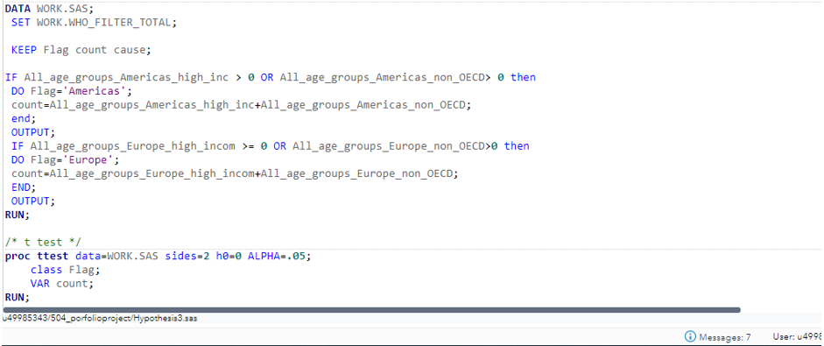

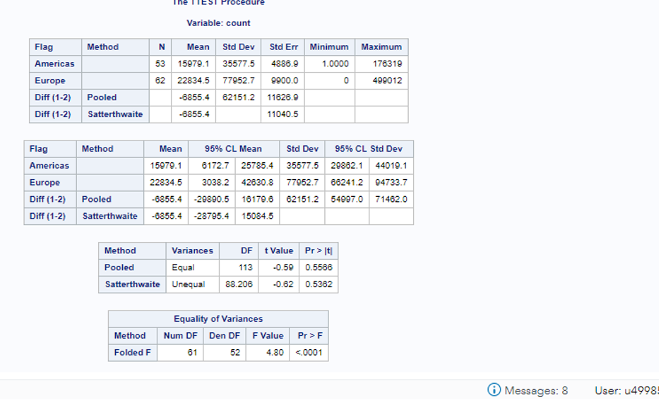

*Note : Extracted using snipping Tool*

Based on the t-test results there is no significant difference between the mortality rates of developed countries. The NULL hypothesis is accepted in this case.

**Figure 7:**

Tableau Bubble chart to compare mortality rates in America and Europe

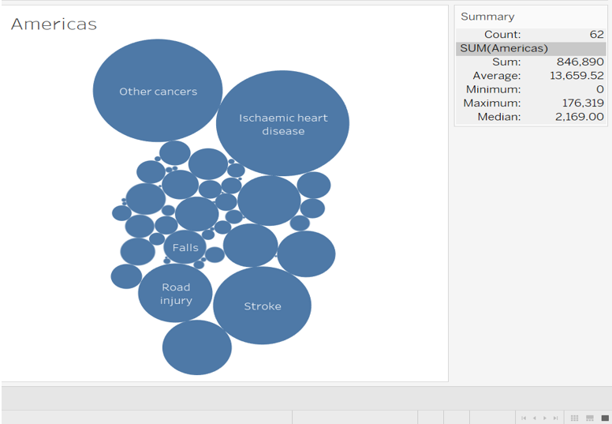

*Note : Extracted using snipping Tool*

**Figure 8:**

Tableau Bubble chart to compare mortality rates in America and Europe

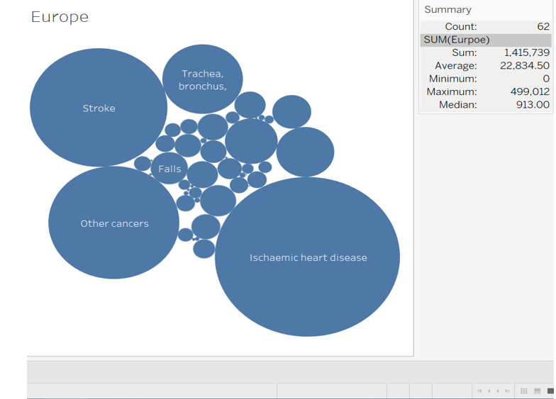

*Note : Extracted using snipping Tool*

Based on the tableau dashboards there are no significant difference between regions of similar development and economic status. The major differences that we can find is America have a higher Road accident count compared to Europe mainly because of the high speed freeways in the country.

**Hypothesis 4**

Mortality rates between developed and developing/underdeveloped nations comparison

**Figure 9:**

SAS Program for T-Test and Results

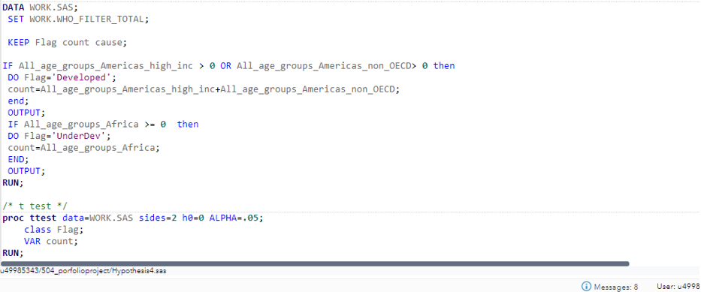

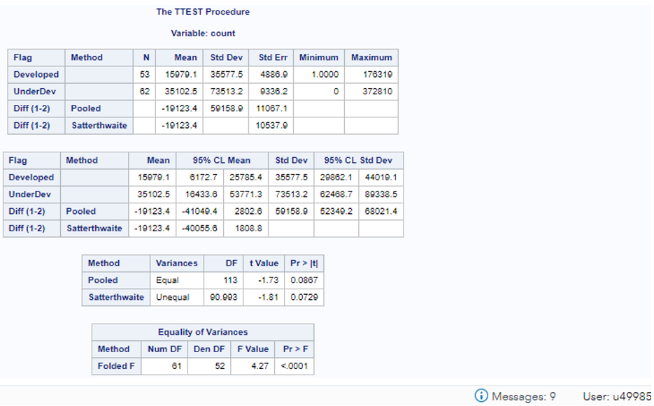

*Note : Extracted using snipping Tool*

The results shows that there is considerable difference in mortality rates between developed / underdeveloped nations

**Figure 10:**

Tableau Bubble chart to compare mortality rates in Africa and America.

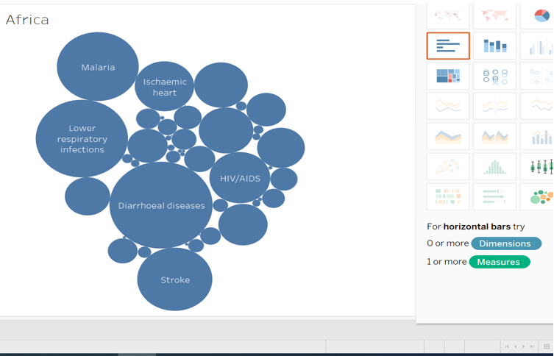

*Note : Extracted using snipping Tool*

GitHub Link : <https://github.com/renjeev/Capstone_Project.git>